Foundations of World History
Unit II – World Religions
Unit Exam

Choose the letter that BEST answers the question or completes the sentence.

Multiple Choice – 1 point each
- Buddhism spread across Asia mostly as a result of
a. trade. b. conquest.
c. missionary efforts. d. pilgrimages by the faithful.

- In Buddhism, the release from selfishness and pain is known as
a. sangha. b. dharma. c. moksha. d. nirvana.

- The social class system that came to be known as the caste system was established in India by
a. Hittites. b. Aryans. c. Hindus. d. India’s first residents.

- The most sacred writings of the Jewish religion are the first five books of the Hebrew Bible, known as the
a. Torah. c. Ten Commandments.
b. Old Testament. d. Ark of the Covenant.

- Hinduism and Buddhism have a common belief in
a. many gods. b. reincarnation c. the caste system. d. the sacredness of all life.

- In the Hebrew tradition, a covenant is
a. prophecy about the future.
b. a law handed down by God to humanity.
c. a mutual promise between God and humanity.
d. an ornamental chest for storing religious documents.

- Varnas, the name given the different groups of the original caste system, came from a word that means
a. skin color. b. nobles. c. purity. d. social system.

- The two items below that are most similar are
a. nirvana and varnas. c. ethical monotheism and Hammurabi’s Code.
b. moksha and nirvana. d. the Ten Commandments and the Four Noble Truths.

- According to the Torah, Moses did all of the following EXCEPT
a. lead the Hebrews out of Egypt.
b. reveal Yahweh’s commandments to the Hebrews.
c. unify the people of Canaan into one kingdom, Israel.
d. grow to adulthood as the adopted son of a princess.

- Jain monks wear masks over their faces
a. to keep from breathing impurities in the air.
b. to keep from harming even an insect.
c. to protect each breath of atman, the soul.
d. to show disdain for the caste system.

- The emphasis on right conduct and the worship of one God is called
a. the Torah. c. the Four Noble Truths.
b. the Ark of the Covenant. d. ethical monotheism.

- The Hebrews believed that God protected them because a. of
a. covenant. c. of annual ceremonies.
b. of ritual sacrifice. d. they are human.

- Israel’s King Solomon was known for all of the following EXCEPT
a. constructing a great temple c. wisdom.
b. building a trading empire. d. unifying the 12 tribes.

- The Ten Commandments became the basis for
a. the civil and religious laws of Judaism.
b. the idea of the promised land.
c. Moses’ belief that Hebrews could escape Egypt.
d. the division of Israel into two separate kingdoms.

- Hinduism and Buddhism differ significantly in their beliefs about
a. reincarnation. c. the cycle of history.
b. the caste system. d. perfect understanding.

- Roman rulers opposed Christianity because Christians __________.
a. were mostly Jews.
b. called for the overthrow of Roman rulers.
c. ignored wealth and status.
d. would not worship Roman gods.

- The Jewish Diaspora refers to __________.
a. the destruction of the Temple in A.D. 70.
b. the years the Jews were slaves in Egypt.
c. Jerusalem.
d. the forced dispersal of Jews.

- What were the reasons that Christianity spread throughout the Roman Empire?
a. It embraced all people: men and women, rich and poor.
b. Rome’s excellent roads encouraged the exchange of ideas.
c. Jesus promised eternal life.
d. All of the above are true.

- What is the main source of information about the life of Jesus of Nazareth?
a. the Nicene Creed
b. Augustine’s book, City of God
c. the Epistles in the Christian Bible
d. the Gospels in the Christian Bible

- What does Islam mean in Arabic?
a. “one who has submitted”
b. “there is no god but Allah”
c. “submission to the will of Allah”
d. “Muhammad is the messenger of Allah”

- What are the Five Pillars of Islam?
a. the various divisions of Islam
b. the major duties required of all Muslims
c. the times during a day when Muslims must pray
d. Muhammad and the four leaders who followed him

- Which of the following is NOT one of the Five Pillars of Islam?
a. faith b. prayer c. fasting d. military duty

- What system of law regulates the family life, moral conduct, and the business and community life of Muslims?
a. shari’a b. Sunna c. Five Pillars d. umma

- Who did Muslims consider the “people of the book”?
a. the Greeks b. only Muslims c. Zoroastrians d. Jews and Christians

- The Qur’an and what other work form the shari’a, or body of Islamic law?
a. the Five Pillars b. the Sunna c. the hajj d. the Hijrah

Interpreting Charts

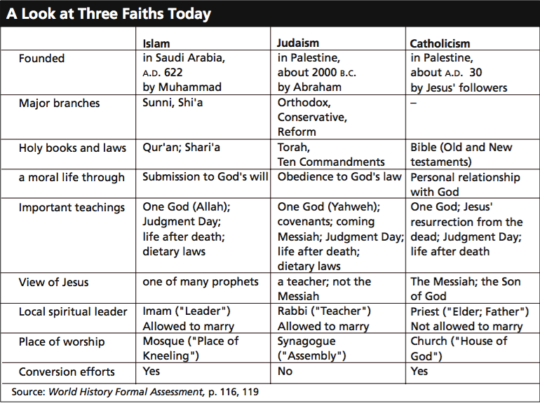

Multiple Choice – 1 point each
- In which faith(s) are spiritual leaders required to remain unmarried?
a. Islam b. Judaism c. Catholicism d. Islam and Catholicism

- Which faith(s) make no efforts to convert nonbelievers?
a. Islam b. Judaism c. Catholicism d. Judaism and Islam

- In which faith(s) is the spiritual leader called by a term that means “Leader”?
a. Islam b. Judaism c. Catholicism d. all of the above

- What are two important teachings that are common to all three faiths?
a. Judgment Day and dietary laws c. one God and life after death
b. one God and dietary laws d. Judgment Day and Five Pillars

- How do Muslims lead a moral life?
a. through obedience to God’s law c. through a personal relationship with God
b. through submission to God’s will d. through following the Five Pillars

- What important teaching or custom is shared by only two of the three faiths?
a. dietary laws c. life after death
b. Judgment Day leaders d. unmarried spiritual

- In which faith is the spiritual leader called by a term that means “Teacher”?
a. Islam b. Judaism c. Catholicism d. all of the above

- On what subject do the three religions hold different views?
a. Judgment Day c. Jesus’ identity
b. life after death d. use of local languages

- What is similar about the beginning of all three faiths?
a. Each has several branches.
b. Each was begun before A.D. 600.
c. Each was begun in Southwest Asia.
d. Each was begun within the same 2,000-year period of history.

- How do Catholics lead a moral life?
a. through obedience to God’s law
b. through submission to God’s will
c. through following the Five Pillars
d. through a personal relationship with God

Extended Response: (15 Points) Using the space provided on your answer sheet to answer the following question. Answers should be written in a fluid, well-structured paragraph (or two).

Explain the development of one of the following religions – Hinduism, Buddhism, Judaism, Christianity, or Islam.

Consider the following when answering the question:
Where did the religion develop?
Why was the religion created?
Why was the religion appealing to its followers?
What are the core beliefs of the religion?
How AND Why AND Where did the religion spread?

